The Dimensions of Data Quality Testing
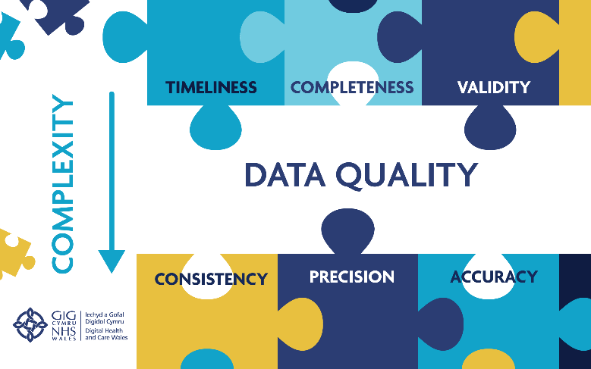

The TIMELINESS of data refers to whether the data has been reported within agreed timescales.

The COMPLETENESS of data refers to whether the submitted data that has been provided is complete - i.e. from a dataset structure perspective, is all the expected data present?

The VALIDITY of data refers to whether the submitted data has been provided in the agreed format and, where applicable, is populated with a nationally-agreed value as defined in the NHS Wales Data Dictionary.

The CONSISTENCY of data refers to whether related data items are consistent with one another. Such a test can be applied to data items within the same data set (e.g. a record that indicates a patients date of birth is after their appointment date should be considered inconsistent and would require investigation) or could be applied across multiple data sets (e.g. a comparison of activity levels in two, or more, data sets).

The PRECISION of data refers to whether the submitted data has been provided to the necessary level of detail (e.g. the depth of clinical coding to ensure the cause of injury has been identified where an injury has occurred).

The ACCURACY of data refers to whether all the submitted data is a true reflection of the activity it is intended to reflect. For example, has a healthcare event that has been submitted to a national database actually taken place?

When testing the quality of submitted data the dimensions of ‘timeliness’, ‘completeness’ and ‘validity’, whilst distinct, are effectively monitored as one in practical terms. For example, checking mechanisms for the ‘validity’ of submitted data will invariably require a degree of checking of ‘completeness’ to be effective. Similarly, some ‘validity’ checking will have a ‘timeliness’ component (e.g. clinical coding information) and this will also be reflected in the ‘validity’ check.

The dimension of ‘accuracy’ mostly relates to the use of [external] audit to confirm that data held on the national databases is a true reflection of the local records in individual Welsh NHS organisations.

